

Task–training for Dozer CAT D10

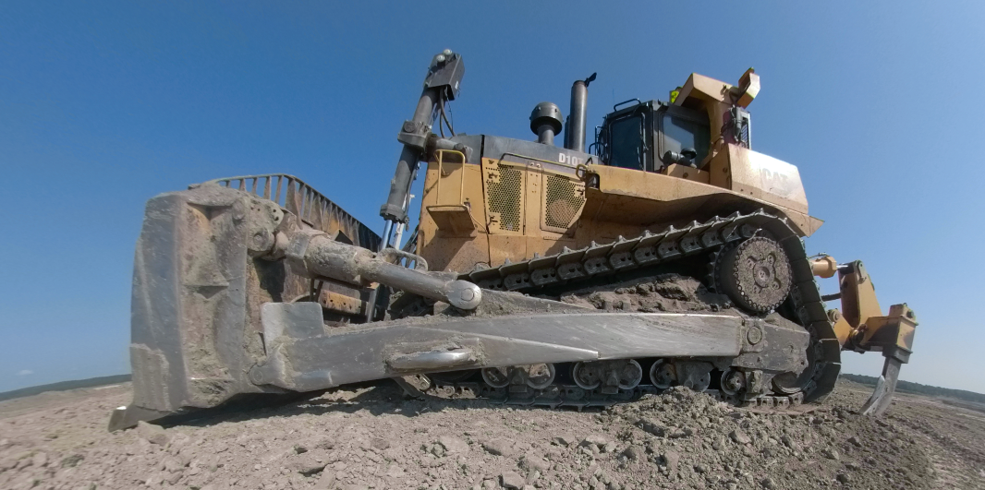
Figure 1 - Dozer CAT D10

07/05/2018

This task training outline is provided solely for training purposes and should not be considered a substitute for the recommendations of the equipment manufacturer or MSHA or OSHA requirements

Contents
Pre-shift inspection 3
General Task 3
Complete Job Safety Briefing (JSB) 3
Walk-around inspection 3
Fluid levels/Mechanical and Safety features 3
Pre-operational inspection 4
Temporary Shutdown 6
Long-Term Shutdown 6
Radio Communication 6
Operational procedures/ Safe Equipment Operations 7
Push Scrapers 7
Ripping 7
Towing 9
Roading 9
Working in the Pit 9
Enter and Exit Shop 10
Emergency Action Procedures 10
What to do in case of emergency 10
Summary of specific incidents - Dozer 10

Pre-shift inspection

General Task
One of a heavy equipment operator’s most important responsibilities is the machine inspection. Inspections not only ensure the operator’s own safety but also the safety of everyone else on your jobsite.
When an operator finds a break line leakage, a loose hose fitting, seat-belt not functioning, horn not working or some other problem before a failure, he or she can avoid injuries and incidents, minimize downtime, and save time and money. That’s a lot of added value for a process that only takes a few minutes.
Operators spend much time with equipment that they know it very good. That’s why they should also engage their senses of sight, smell, sound and touch to reveal clues about the status of a machine. Operators should always watch out for each other and they should never assume, but keep a good communication.
- Horseplay will not be tolerated.
- No tailgating.
- No passing or racing.
- If sleepy, stop and walk around and stretch.
- Do not operate if a physical or psychological problem exists.
- Watch out for other operators.
- When in doubt about a situation, stop and check situation or call supervisor.
- Clean windows and lights whenever necessary.

Complete Job Safety Briefing (JSB)
Always fill out Operational Safety Checklist and mark areas that needs repair.

Walk-around inspection
Walk around dozer and check for obstructions, people and “Do Not Operate” tags. If safety defects exist, tag out and DO NOT OPERATE until repaired!

Fluid levels/Mechanical and Safety features
- Check for loose bolts and structural damage.
- Inspect implements for damage or excessive wear.
- Inspect implement cylinders for leaks, damage, or wear.
- Check radiator guard for trash build-up.
- Check tracks for damage, wear, and proper tension.
- Check rollers for leaks and wear.
- Inspect final drives for leaks.
- Check ripper tip and shank guard.
- Mount machine properly
- Check for engine oil.
- Inspect engine compartment for leaks or potential problems.
- Check for coolant and check cooling system for leaks or trash build-up.
- Check hydraulic sight glass for oil.
- Check transmission and torque converter oil level.
- Check fire extinguisher for seal and tag.

Pre-operational inspection
Not only is important to check the cabin because of the law, but also to ensure safety of employees, safe operation and overall safety. A good inspection will give you a better understanding of the systems and items inside the cab.

Controls/How to start
- Insure all controls are in the neutral position.
- Check that parking brake is set.
- Turn on master switch. (Located in left access door)
- The coolant flow, engine oil pressure, and the alternator light should come on.
- Press panel test switch.
- Use ether start if necessary.
- Turn switch to start. If difficulty in starting:
Use ether button every two seconds until engine starts. Do not exceed 30 seconds continuous cranking. Allow two minutes for starter to cool before cranking again.
- Turn on lights.
- Check lights.
- Recheck oil reservoirs for proper level.
In cab:
- Check horn.
- Check back-up alarm.
- Check windshield wipers
- Check glass for cracks, ice, and dirt.
- Adjust seat.
- Fasten seat belt.
- Fill out safety check list.
- Use horn signals - one for forward, two for reverse.

Transmission Direction Selector

With your hand on the left-hand console rotate the control with your thumb in order to change the direction of the machine. Press the top of the control in order to move the machine into FORWARD. Press the bottom of the control in order to move the machine into REVERSE. Align the marks on the control in order to select Neutral.

Transmission Gear Selector

With your hand on the left-hand console Press the transmission upshift point (top yellow button) in order to upshift the transmission to second gear. Press the upshift button again in order to upshift the transmission to third gear. Press the transmission downshift (lower yellow button) in order to downshift the transmission to second gear. Press the transmission downshift again in order to downshift the transmission to first gear.

Steering Clutch and Brake Control

The FingerTip Control (FTC) allows simultaneous control for the steering system and simultaneous control for the transmission system.

There are two steering clutch/brake levers. The lever on the left controls the left steering clutch/brake. The lever on the right controls the right steering clutch/brake.

Left Steering Clutch and Brake Lever - Pull the lever backward. This disengages the steering clutch. This will also steer the machine to the left. The turning radius is controlled by the force that is exerted on the lever. When you exert more force on the lever, the turning radius will be smaller.

cd The turning radius is controlled by the force that is exerted on the lever. When you exert more force on the lever, the turning radius will be smaller.

When you feel pressure, the steering brake begins to engage. Completely pull the lever backward. This applies the brake for a pivot turn.

Park Brake Control

Parking Brake - This switch (located on the side of the left arm console) engages the parking brake. This switch also locks the transmission in NEUTRAL. The machine should not move when the parking brake switch is engaged. When the parking brake switch is engaged, the parking brake indicator on the dashboard will light. Do not use the parking brake for stopping the machine.

Engaged - Depress the upper portion of the rocker switch in order to engage the parking brake. This will also lock the transmission in NEUTRAL.
Disengaged - Depress the lower portion of the rocker switch in order to disengage the parking brake.

Adjustable Arm Rest

Fore/Aft Adjustment - Slide the lever (located on the front side of the console toward the operator in order to release the fore/aft mechanism.
Move the armrest to the desired position and release the lever.
Height Adjustment - Depress the right end of the rocker switch (located on the front side of the console) in order to lower the armrest. Position the armrest at the desired height. Release the rocker switch. Depress the left end of the rocker switch in order to raise the armrest.

How to shutdown

Temporary Shutdown
- Look for and park in area clear of other equipment when:
- Talking with supervisor.
- Having mechanical troubles.
- Taking lunch and breaks.
- Cleaning tracks when going to new area
- Lubing and fueling
- Do not park close to highwall or spoil.
- Maintain minimum distance of ten feet between equipment.
- Place transmission in neutral.
- Set park brake.
- Lower all raised equipment.
- Dismount and mount facing machine using proper handholds – three points of contact.
- Prior to moving, make walk-around and use proper horn signals.

Long-Term Shutdown
- Find level area.
- Maintain minimum distance of ten feet between equipment.
- Do not park close to highwall.
- Place transmission in neutral.
- Set park brake.
- Lower all raised equipment.
- Dismount properly and clean tracks.
- Idle engine five minutes prior to shutting off.
- Turn off all switches
- Turn off master switch.
- Dismount facing machine and use proper handholds – three points of contact

Radio Communication
- Do not use radio unnecessarily.
- Keep conversations short and business-like.
- Maintain good communications with other truck drivers.
- If in doubt about a situation, use the radio.
- Follow FCC regulations.

Operational procedures/ Safe Equipment Operations

Push Scrapers
1. Spot Scraper.
2. Park at an angle so that scraper can pull in on the cab side, whenever possible.
3. Always square up dozer with scraper.
4. Hook up with minimum impact.
5. Always be alert to:
a) Scraper or dozer sliding.
b) Jackknifing.
c) Scraper hooking.
d) Frost and mud.
e) Keep dozer low.
6. Stop pushing when scraper pulls away or turns tractor.
7. Always be alert to:
a) Knocking down monuments.
b) Grade stakes.
c) Other equipment.
d) Power cable.
e) Rocks.
f) Personnel.
g) Weather conditions.
h) Highwall.
8. Stay within permit boundary.
9. Know the meaning of grade stakes and soil color change.
10. Do not push two scrapers that are push-pulling.

Ripping
1. Always check ripper for shank.
2. The tip should be checked a minimum of every hour.
3. If the ripper tip is lost, cease ripping immediately. Ripping without a tip causes extensive damage to the shank.
4. Use proper pitch and depth for soil material conditions.
5. Never turn with ripper in ground. Turning with as little as six inches of shank in the ground can result in a broken shank.
6. Rip downhill whenever possible.
7. Only expose enough shank necessary for the job.
8. Under rocky conditions, use a lower gear.
9. Always be alert to:
- Track spinning.
- Undercarriage damage due to frost chunks and rocks.
- Monuments.
- Under frozen conditions, do not rip sideways on a slope.
- Trail cable.
- Other equipment.
- Fire when ripping coal.
- Sumps.
- Highwall slough.

Dozing
- Supervisor and operator inspect work area and develop a plan of action.
- Always prepare an access trail to the immediate work area.
- Rip area if necessary.
- Be alert to:
a) Spillage on ramps and roadways.
b) Loose rocks.
c) Undermining banks.
d) Overhanging material.
e) Covering up water lines and power cable.
f) Keep soil segregated.
- Maintain adequate and proper drainage.
- Get a full load on blade.
- Keep work area level.
- Push in proper gear. DON'T LUG MACHINE.
- Always look before backing.
- Always be alert to:
a) Monuments.
b) Grade stakes.
c) Other equipment.
d) Power cable.
e) Rocks.
f) Personnel.
g) Weather conditions.
h) Highwall.
- Avoid dozing on slopes greater than 3:1. – sideways
- When working slopes, be aware of:
a) Hooking rocks.
b) Loose or wet material.
c) Frozen ground (Skate factor).
d) Other equipment and personnel (especially when cresting hill).
e) Getting dozer too high.
f) Engine oil pressure.
- Carry ripper and blade as close to the ground as possible when working slope.
- Before working slope, make sure the track tension is properly adjusted (sprocket wear, roller flanges, etc.).
- Visibility is limited when working on coal stockpile.

Towing
- When machine gets stuck, do not increase engine speed or rock, causing tracks to spin.
- Evaluate situation and determine plan of action.
- Have large enough anchor for braking when towing a free-wheeling vehicle.
- Gloves shall be worn whenever handling tow cable.
- Examine tow cable to be used.
- Make sure the cable is the proper size for the job.
- If the cable is determined to be safe and has the proper capacity, it is ready to be used. At no time should anyone stand near the cable while pressure is on the cable. STAND BACK!
- If the cable is damaged during use or thought to be unsafe, then it shall be reported to your supervisor.
- After the cable is used, it will "at that time" be taken back to the cable tree with one end of the cable being placed up on the tree.
- Be alert to what is ahead of you as well as the towing operation behind you.
- Do not push other equipment unless equipment is designed to be pushed.

Roading

- Use moderate speed when roading.
- Always road in forward gear.
- Use proper portion of road and proper traffic pattern when roading.
a) When slippery, stay away from shoulder.
b) Under good conditions, run as close to shoulder as possible.
- Always be alert while roading.
- Carry dozer and ripper low when roading on frozen ground.
- Be sure of roadway:
a) Power cable.
b) Topsoil.
c) Water lines.
d) Unknown short cuts.
Never drive on a road of which you are unsure.

Working in the Pit

- Check highwall when entering pit.
- Check area for:
a) Haul trucks.
b) Loader.
c) Pumpers, pumps, water hoses, sumps.
d) Blades.
e) Light vehicles.
- Check location of power cables.
- Know traffic pattern prior to entering pit ramp.
- Do not work within swing radius of dragline.
- Always look in the direction of travel.
- Follow procedures for ripping.
- Be aware of visibility limitations.

Enter and Exit Shop

- Sound horn before entering shop.
- Visibility problems:
a) Daylight to dark shop.
b) Dark to light shop.
c) Restrictions
- Have flagman aid in entrance and exit.
- Enter and exit at a slow speed.
- Do not enter bays that are not designed to handle tracks.
- Perform walk-around prior to exit.

Emergency Action Procedures

What to do in case of emergency

Emergencies

1. In case of fire:
a) Shut down engine.
b) Turn off master switch.
c) Activate fire suppression.
d) Stay clear. Remember no machine is worth your life.
2. If dozer breaks traction and begins to slide, drop dozer and ripper as quickly as possible.

General Maintenance

1. See temporary shutdown procedure.
2. When maintenance is being performed, no more than one person shall be in the cab.
3. Use caution when climbing around on machine.

Summary of specific incidents - Dozer

1. An employee twisted his ankle when he stepped on uneven ground while dismounting a dozer during dark conditions. This became a LTA. Dismounting and mounting dozers pose some very serious hazards to the operator. Especially when you throw in the dark and muddy conditions where the dozers work. Always maintain at least three points of contact and DO NOT take this process lightly. Be careful.

2. While ripping subsoil the operator attempted to rip across a 3:1 slope, which resulted in a broken ripper shank. Ripping cross ways on a slope is asking for an expensive, time consuming accident. Always try to rip slopes vertically.

3. A dozer was ripping on a subsoil pile, when it lost traction, slid side ways and tipped over when it encountered a 4-foot drop off. Dozers are extremely stable, however they will tip. Getting a dozer sideways on a frozen slope will, in most cases put the dozer in an uncontrollable situation. Always travel vertical on frozen slopes.

4. While side cutting a spoil bank, a rock fell off the ledge and damaged the cylinders. Undercutting while side cutting, cutting a slope higher than the dozer blade and lack of attention were the cause of this accident. Watch the material and the slope you are cutting at all times.

5. While dozing near a loading shovel, the shovel swung and broke the dozer arm. Equipment should NEVER operate within the shovel tail swing radius while the shovel is in operation.

6. A dozer grill and radiator were damaged when a frozen chunk came over the top of the dozer blade and wedged between the blade and the grill. The operator must pay close attention to the material being dozed at all times.

____________________________________________________________________________________________

This signature acknowledges that you have received the copy of the task training outline.

Trainee Signature ________________________________________________

Trainer Signature ________________________________________________

Supervisor Signature _____________________________________________

Date _________________________________

